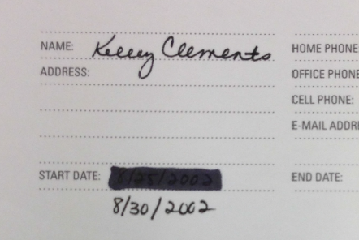
Transcript of Kelley Clements, Executive Assistant to Professor James P. Chandler, Stenographer’s Notebook

Date: 8/30/2002
Actual page images enclosed (includes [verified] notations)

We’ll stretch the comments/conversation out of Paul
Figure 1: Note “8/25/2002” is visible under the blacked out section.

[Paul Martin, Lawrence Livermore National Laboratory (LLNL)] as long and as far as we can] [verified]
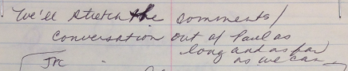

[JPC (James P. Chandler) – call into [unintelligible] – nothing urgent]

Chandler has to keep [unintelligible] at bay as long as we can

.5

Lynn Mattice
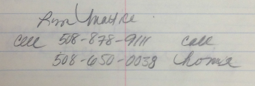
Cell 508-878-9111 cell
508-650-0038 home

[Chief Security Officer, Boston Scientific; board member, National Intellectual Property Law Institute (NIPLI)]] [verified]

[On Sep. 20, 2002, Chandler facilitated a meeting among JPC, Leader Technologies’ Michael McKibben, Lynn Mattice and Kelley Clements at Boston Scientific] [verified]

Pam Paychex
(703) 698-6910 x 9624

-complaint
-bill

-imposed bill for work they never did

---------------------
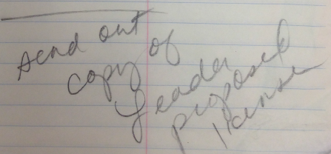
Send out copy of Leader proposed license [re. likely to Eurotech re, CRADA given timing]

<DC Bar -
<Pennsylvania Bar –

-file for a counter-claim
-costs you have to pay to KJA and JPC

-Chandler to call Kristen today –

$180

DC Bar –
PA Bar

Kristin Achterhot
-depositions
-Piper Rudnick bill
<-send copy of dismissal to C. Berndtson>
<pay Paul @ Apertures>
<call George Emerson>
-Patent Bar Review

-ICI – 2002 –
Back in Sep.
-Dec or Jan
-Counterfeiting-

Patent Bar
Hotels –
add list of local restuarants
local hotels
Metro Maps
-web site problems
nipli.net
ninpl.org
logo cut out – Ruth-idea list

Christmas Cards
Postage – bulk rate
Neopost

-faculty letter
-Dec 10-11

<Describe course
Highlight>

<-send out w/ letter from [unintelligible]>

>Marketing letter – flyers w/ highlights
>Faculty letter – after agreed
Outlines
Where course
Who coordinate
Materials
-what will they
>-participant letter that gives specifics

VENDORS

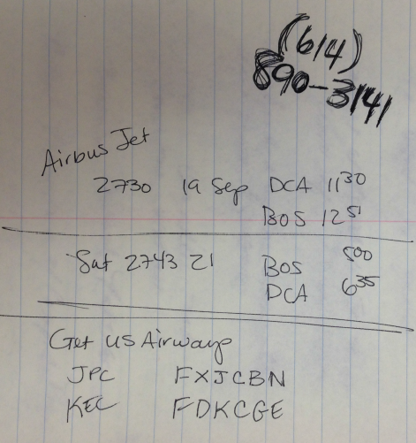
Mail to Chris
Geier
In Med[unintelligible]
Case

Niciketta @Boyulto
301-519-7355

(614) 890-3141 [Leader Technologies’ office number] [verified]

Airbus Jet
2730 19 Sep DCA 11:30
BOS 12:51
Sat 2743 21 BOS 5:00
DCA 6:35

Get US Airways
JPC FXJCBN
KEC FDKCGE

9/6/02

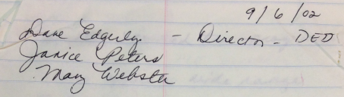
Dave Edgerly [sic. Dave Edgerley] – Director – DED
[Montgomery County Department of Economic Development
1995 – 2006 (11 years), Rockville, Maryland] [verified]

Janice Peters [sic. Janis Peters] [DED Manager of business development] [verified]
May Webster

Janice works in the county

-Chandler was a tenured Professor @ UMD
-@GWU – 18 years

-taught at Wash U St. Louis
-Univ of Mississippi

-JPC headed up the computer law center @ GWU

-1993 –Chandler took Emeritus status

-Business Method Patents

-Patent Protection of Computer Programs [published by Univ. of Minnesota Law School] [verified]

-Chandler started the program

-NIPLI offers a wide range of courses

>we do not draw from GWU at all – it is totally independent

>we do research on a vast scale of IP
-we’re like a university of intellectual property (cover the universe)

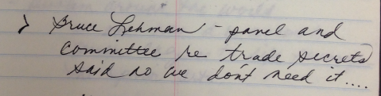
>Bruce Lehman – panel and committee re trade secrets said no we don’t need it …

>NIPLI and Chandler drafted that law
-passed unanimously
Signed into law 10/11/96
-most IP lawyers practice under Federal Trade Secret

We are a 501(c)(3)
-no accreditation
We are a CLE provider

-we don’t offer law degrees

Known for biotech cos.
10 x # of IT companies

-we want to do a sizeable relocation

-what is taking place
national and globally

-problem around the world
No one has d.b. access to search engines to sift through the prior art.

-trend of registration system
not examination system

-our gov’t can’t provide searches

Gov’t has decided to go from physical d.b. to electronic d.b.

-Average practitioner goes to search room
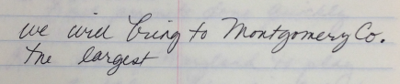
We will bring to Montgomery Co. the largest

-Chandler’s interest is to bring it to his own county.
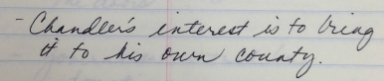
-our discussions are confidential

DED-Staff of 40

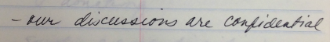
-specs
Size, building, location
How it fits, etc…

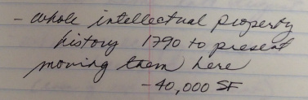
-whole intellectual property history 1790 to present moving them here
-40,000 SF

-many of the docs are old
Require temperature control

Lease environment, real estate, etc.

Doug Duncan
get permits done quickly

Role – State of Maryland to play a role – they will open doors
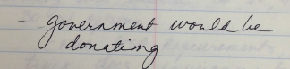
-government would be donating

-surplus property dispositions – GSA

-helped liquidate Naval Ops Center

-Timing – PTO had been seeking approval of Congress
got some late August [2002]

-what we occupy must be already built.
(even if not permanent)

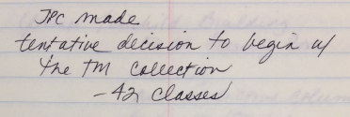
JPC made
Tentative decision to begin w/ the TM collection
-42 [trademark] classes

Patent Classes
-many many more
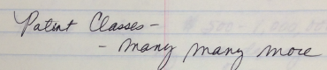
----------

County will search 30-50, 40-50
30 w/ options
-need GSA requirements, specs
truck docs, environmental control, floor loading,
ceiling heights, electrical requirements, how many offices support
the space

-Professional Architects, Engineers,
who on team?

-they will help to identify
Buildings

Former Fairchild Building
50 SF Masonry Boxes
Security
non-restrictive columns
lease 15/SF/year
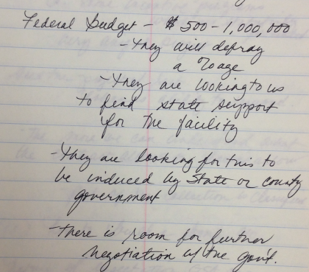
Federal Budget - $500-1,000,000
-they will defray
A %age
-they are looking to us
to find state support
for the facility

-they are looking for this t
be induced by State and County
government

-there is room for further
negotiation w/ the gov’t

-we have to
4-10 mill. Needed

If we get it in place –
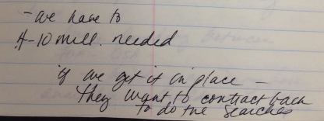
they want to contract back
to do the searches

advance docs required to set up
a meeting with the State would
be helpful

-State has incentive programs
Co. some incentive programs
which are statutorily
presented
-very unique project

See the project w/ rent
Enhances ability to respond

-the more we can understand what
the contract allows or doesn’t allow
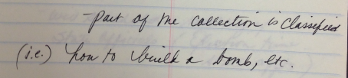
-part of the collection is classified
(i.e.) how to build a bomb, etc.

Nature of expectation GSA may
have-
bridge funding between
FOA-GSA
-building on Navy base
Available – building on DOE campus
where already a secure environment

-they’re paying a fortune for
their facilities in Crystal City

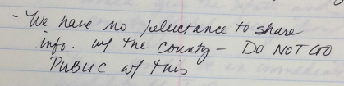
-We have no reluctance to share
Info. w/ the County – DO NOT GO PUBLIC w/ this

-will do a search re what is
already out there

Janis will do

-think about spec

-will schedule meeting w/
State Officials (Election time [Sep-Oct, 2002]
State appts.)
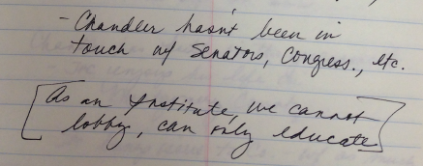
-Chandler hasn’t been in
Touch w/ Senators, Congress, etc.

[As an Institute, we cannot
lobby, can only educate]
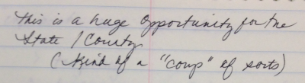
this is a huge opportunity for the
State / County
(kind of a “coup” of sorts)

-could give the state and
county global recognition

-there would be an immediate
Visibility of I.P.

-paper presented to C.I.A
made public
-provide the game to

>programs of NIPLI
>as well as depth

-Reference to Nat’l Sec. Acad.
no info on www

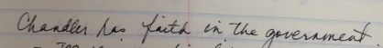
Chandler has faith in the government
-JPC enjoys his life in Montgomery County

-JPC brings issue to Co. w/ as much info as he can and ask
>tax policy
>financing

ombudsman for projects

be credible in a rich business base

$5M (---appropriation) citizens value elementary
school expansion

Doug wants to meet with you.
personally as well

Be responsive and responsible as possible.

If we think we have something we’ll go forward

GSA should pay for this project.

Federal government controls projects
-now we have a facility, revised budget –
-developers are waiting on proposal

Century Technology Park
Germantown, Maryland

Run a 35-60 n the the whole County

-Fairchild Buildings.

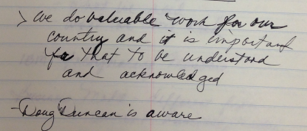
>students from around the world – Michael Schramm

>NIPLI – Board of Directors =-

>We do valuable work for our country and it is important for that to be understood and acknowledged

-Doug Duncan is aware [County Executive, Montgomery County, Maryland] [verified]

-MMO/COUNTY – highly complimentary

I.Exchange Data
II.Sampling of Space
III.Who in State?
IV.GSA Sr. level employee
V.Use agreement between
State and NIPLI
VI.Timing they want
things removed by X-mas
this year [2002]
(they want to get out of the business of searching)
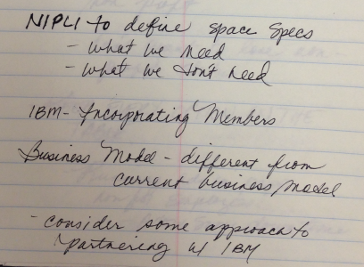
NIPLI to define space specs
-what we need
-what we don’t need

IBM incorporating Members
Business Model – different from current business model [likely The Eclipse Foundation given context]

-consider some approach to
partnering w/ IBM

cadre of buildings
-gov’t services division
Here in Montg. Co.

-he things IBM may have this in their inventory already

-given automation side – this
could be an extraordinary marriage
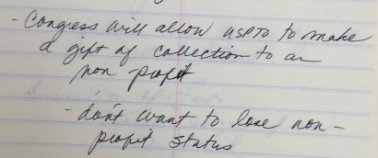
-Congress will allow USPTO to make
a gift of collection to a
non-profit

-don’t want to lose non-profit status

KEEP EVERY OPTION ON THE TABLE.

-Running ads in paper now for Employees . . .
--Allw some down time
They will provide us with personnel if we request it….

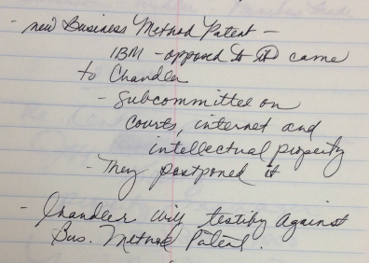
-new Business Method Patent-
IBM – approach to it came to Chandler
-Subcommittee on Courts, Internet and Intellectual Property
-they postponed it

-Chandler will testify against Bus. Method Patent.

-discussion of Festo
-Kodak resigned from
--the Board (NIPLI)

-U.S. Supreme Court in
Opinion by Justice Kennedy
in Festo.
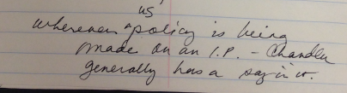
wherever U.S. policy is being made on an I.P. – Chandler generally has a say in it.

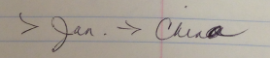
Reagan’s OSTP – Chandler was instrumental in – Bayh-Dole-Stevenson-Wydler-Omnibus Trade Act

-5:00 pm

…
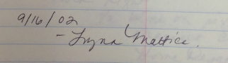
9/16/02
-Lynn Mattice

Hotel Courtyard Marriott
Speen Street
easy to get to

straight out Rt. 90
Mass Pike
Exist 13

Get on Eastbound Rt. 30
Through toll booth

1st light Speen Street
turn right
½ block on right
Marriot Ct yard
Home Depot

1 block from facility
drive on to campus
notify in advance

$179.00 + tax
19th 20th [September 2002, meeting between Lynn Mattice (Boston Scientific), James P. Chandler, Kelly Clements and Michael McKibben (Leader Technologies)] [verified]
3 rooms $119 stand
James Chandler N/S rate preferences
Cancellation
6pm Day of Arrival
#80834805

Chautauqua
Embraer Jet
800-235-9292
50 people
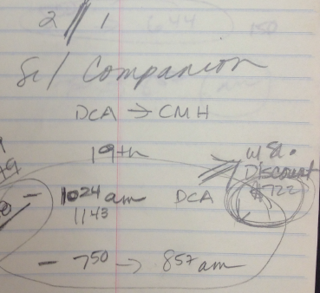
2//1
Sr / Companion

BWI 12:35-1:45
CMH 7:25-8:34am

DCA CMH
19th

183.79
183.79
367.58 10:24am
11:43
-7:50 8:57am
DCA w/ St. Discount $722

Delta nonstop
NW nonstop
[check mark] AW $722
Continental no nonstop
United nonstop
American no nonstop
US Airways 1480
10:24 11:43 50
5:30 6:44 150

7:50 8:57am

BWI 12:35-1:45
7:25-8:34

MARC TRAIN 10:20 – 10:56
$5.00
Aug
-statement
Promissory Note Q1/Q2
New Engagement
TM Status Sheet

